Mateen Olanrewaju May-4-2022

**Computer Network Project 4**

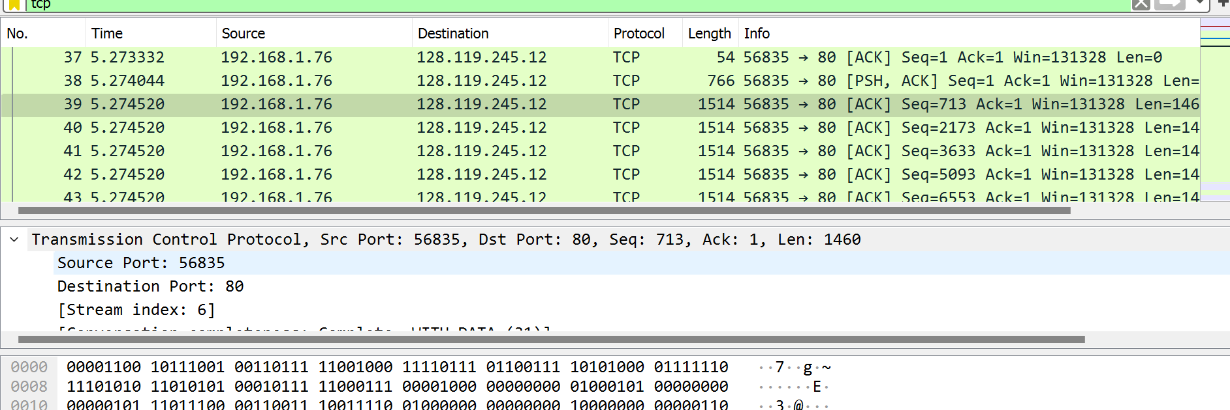

* The IP address is 192.168.1.76
* Source Port: 56835

1. IP address is 128.119.245

Destination Port: 80

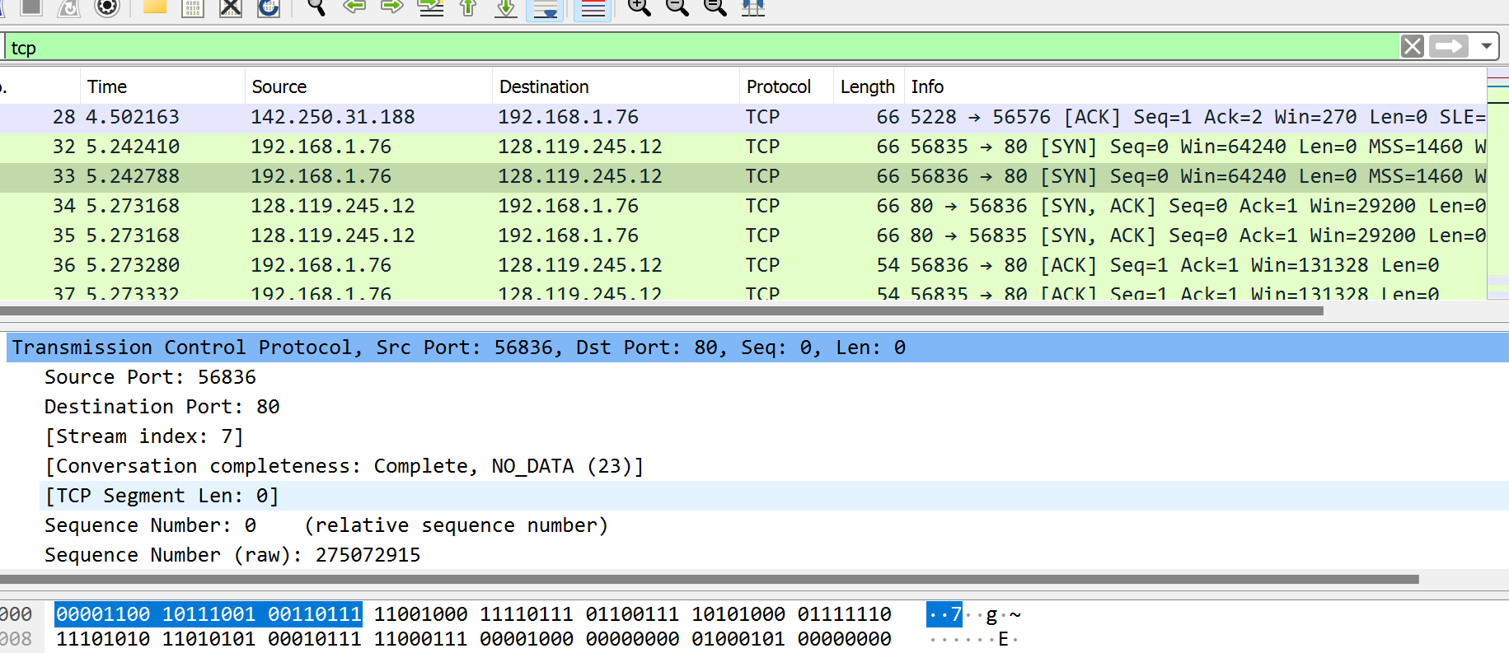

* The sequence number of the TCP SYN is 0.
* 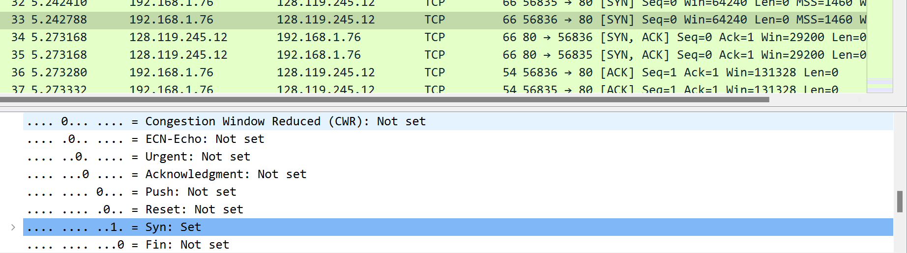

What identified the segment as a SYN segment was the Syn: Set which was highlighted in blue in the screen shoot.



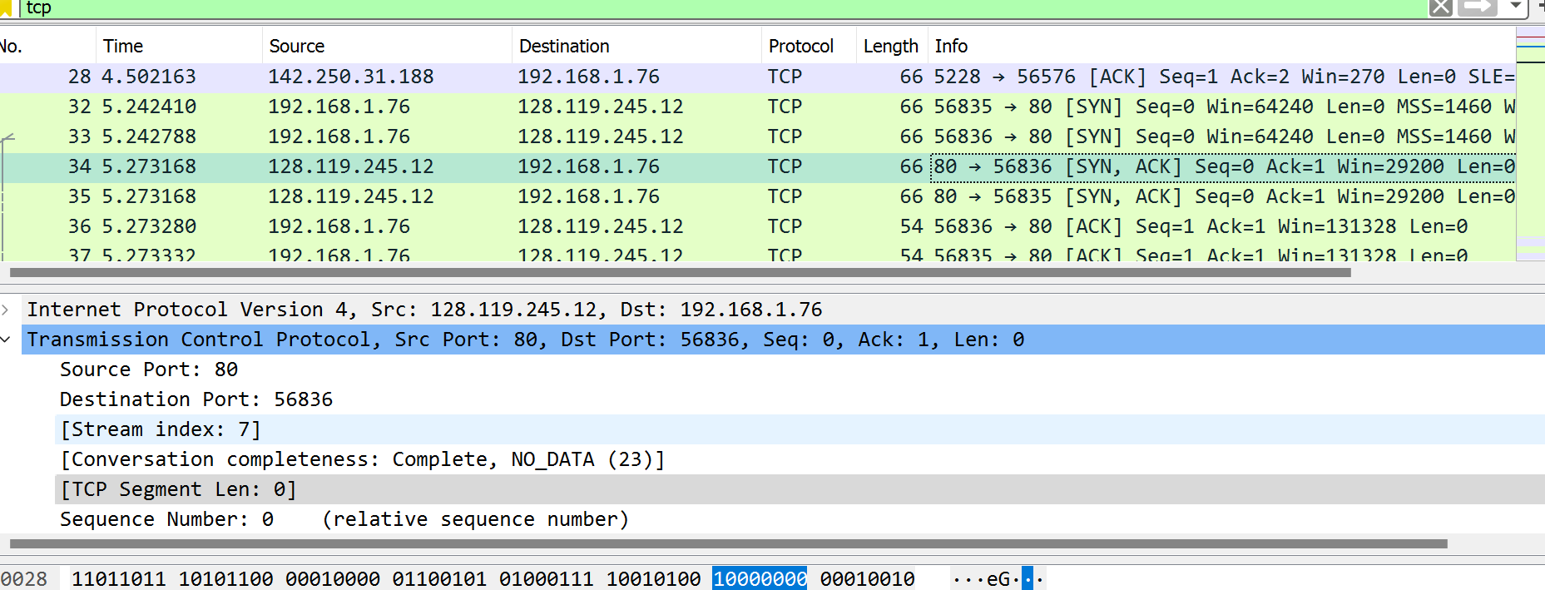

* The sequence number of the SYNACK segment is 0.
* The Value of the Acknowledgement field is 1. Gaia.cs.umass determined that value based on the client side sequence number.

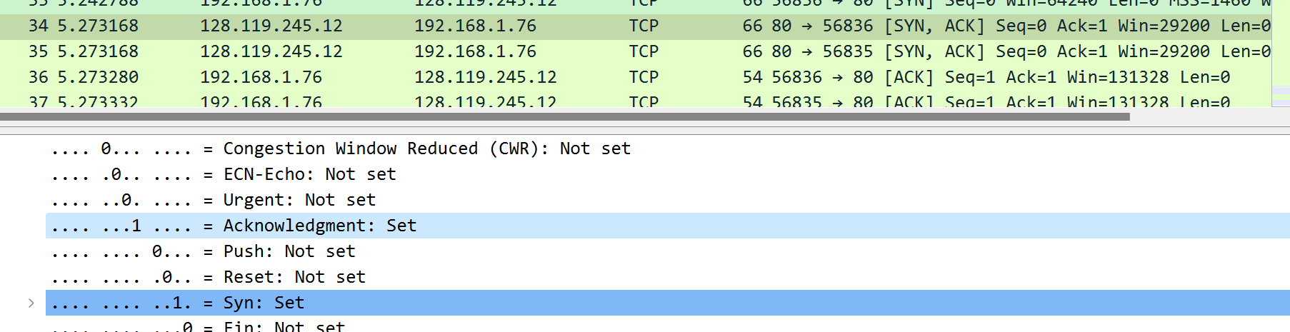

The thing in the segment that identifies the segment as SYNACK segment was the Acknowledge: Set and Syn: Set that was highlighted in the screen shot.



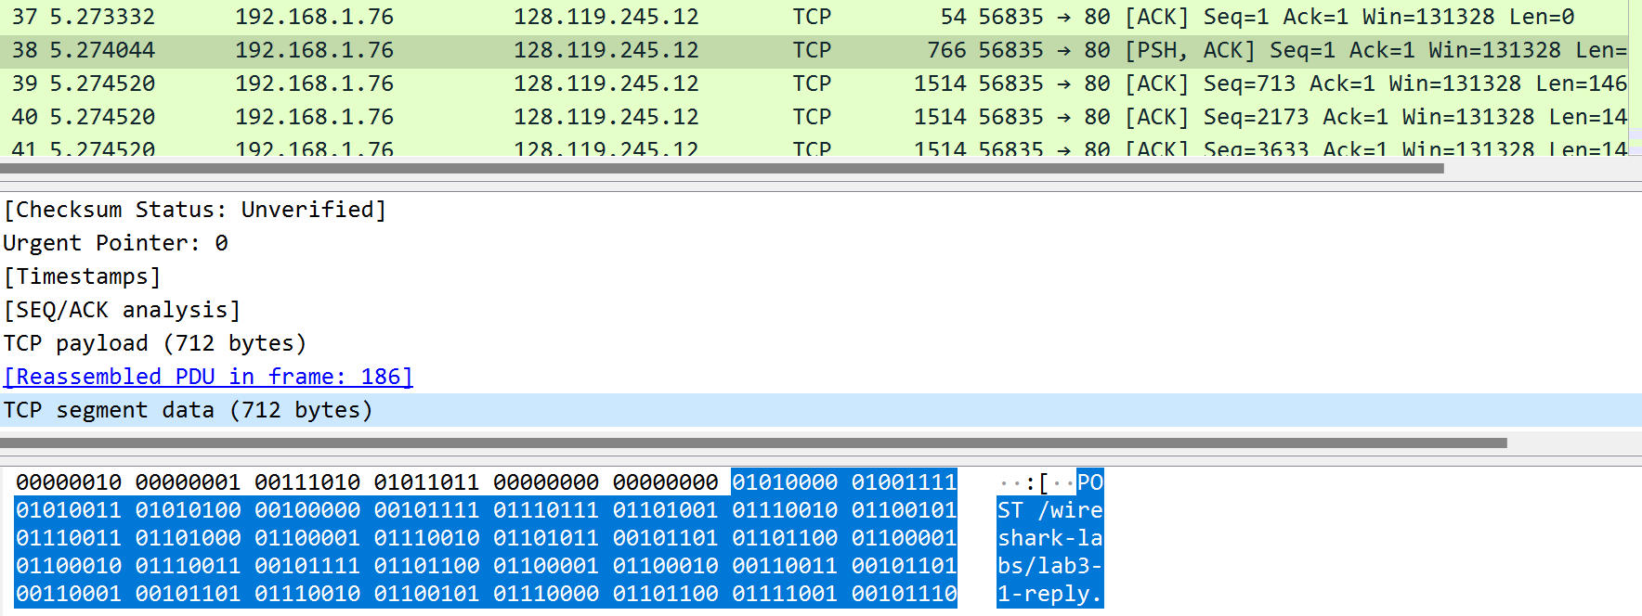

* The sequence number of the TCP segment containing the HTTP POST command is 1.



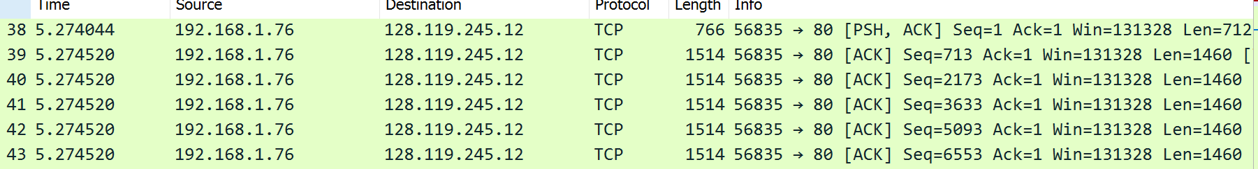

* The sequence number of the first six segment is:

Seq=1

Seq=713

Seq=2173

Seq=3633

Seq=5093

Seq=6553





The Time that each segment was sent was:

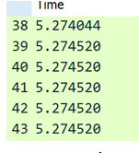





The ACK segment was received at 5.304750.





5.274044. The RTT = **0.030706 seconds**

5.304750 - 5.274044 = **0.030706 seconds**





* The length of the first six TCP segment is

712

1460

1460

1460

1460

1460. So the MSS would be 1460.

8.

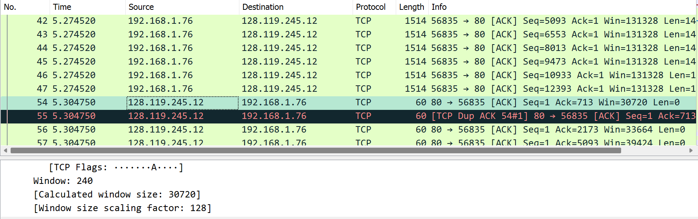

The minimum amount of available buffer is 30720.

9. No, they’re not any retransmitted segments in the trace file because the network condition is good. If it was to happen that means some of the packs were lost.

10.





* The data receiver acknowledges 712 in an ACK.